CTM-I Test Plan

Menu Tab: Security

Screen: User Maintenance - Search

Version 0.1

Menu Tab: Security

Use Case Name | User Maintenance; Search
User Roles | Firm User(CTMI_Firm_Options_Root, CTMI_Firm_Options_Admin, CTMI_Firm_Futuress_Root, CTMI_Firm_Futures_Admin), Market Ops(CTMI_Help_Desk), App Support(CTMI_Root)
Pre-conditions /Assumptions | User has successfully logged into the CTM-I application.
Post Conditions | None
Screenshot | 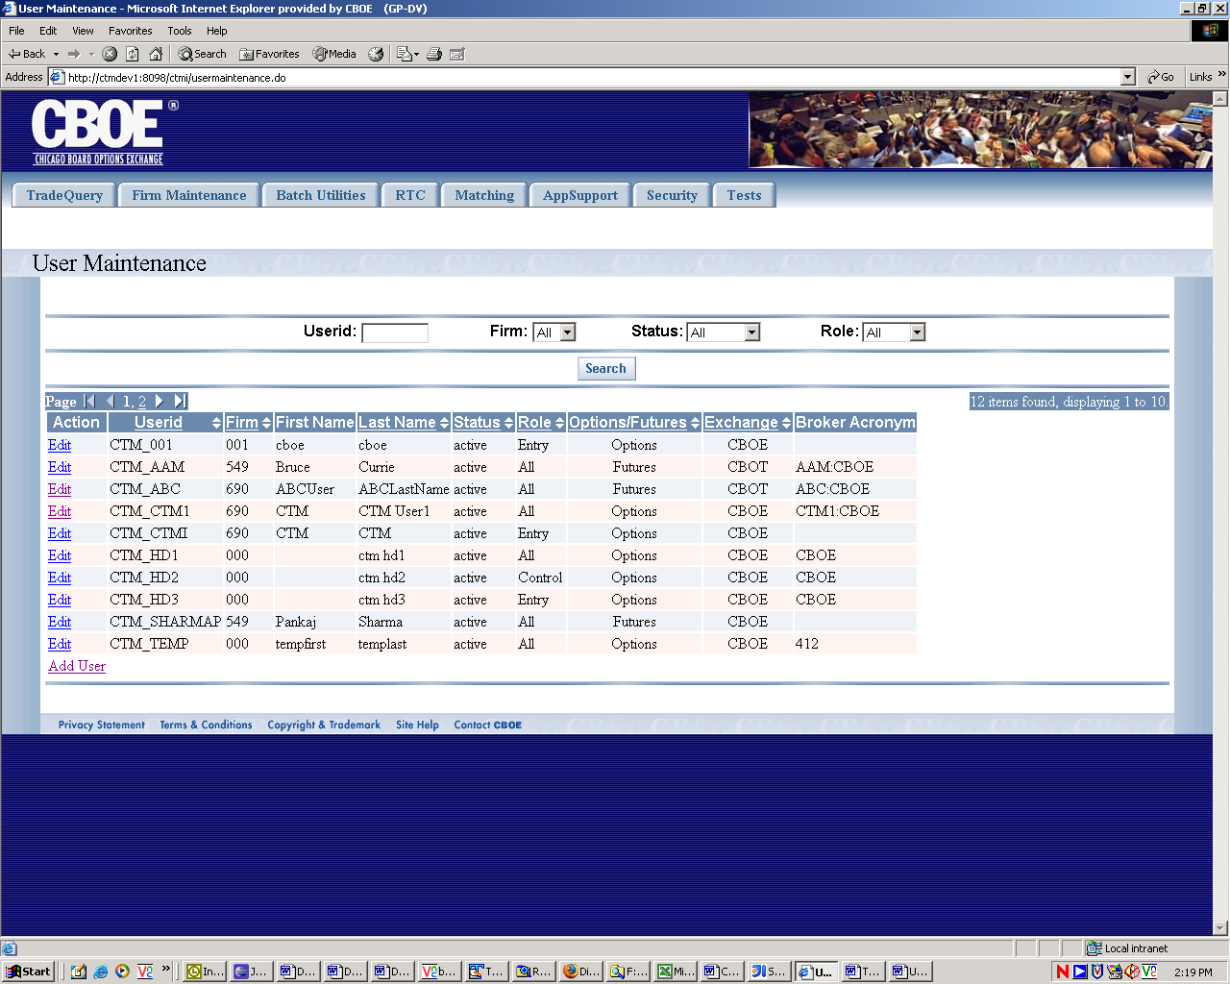
Test Scenario A | User Role : CTMI_Firm_Options_Root, User Id: xxx Password: xxx
 | Action | Expected Out Come | Comments/Results
Test Case 1  Display Authorization Screen | User Clicks on User Maintenance Menu | User Maintenance Screen displays with the four fields at the top to enter one or more search criteria followed by a list of current users and their information that this particular user role has access to. UserId field is a text Box and all others are drop down fields. Firm dropdown field is populated by the user’s Primary Firm and Authorized Firms. | This screen has two parts. Top part with four fields and a ‘Search’ button helps user enter or select search criteria and conduct a search for users this role is able to access. The bottom part is for display of users satisfying the search criteria.
Test Case 2  Search By UserId | User enters a full userid, or just what the userid starts with. For example, entering an “A” would search for all userids that started with “A”. The other Search Criteria defaulted to All user. User then clicks on ‘Search’ button. | The results of the search matching the criteria will be returned at the bottom of the screen with standard paging mechanism. Default sort of the returned results will be on Firm and User Id. A max of 30 rows will be displayed at a time on the screen with more results being available with the navigation bar (for Next, Previous, First and Last) at the top of the result table.  Additionally on the right number of rows returned by query and number of rows being displayed on page are also displayed. | If no matching firms exist no rows are returned.  A max 30 rows of results are displayed on one page. For viewing more results standard paging mechanism is available using navigation bar for ‘Next’, ‘Previous’, ‘First’, ‘Last’ arrows.  If all rows returned are displayed on the first page (meaning no more rows are available) navigation bar is not visible.
Search By Firm | User selects Firm from the Drop Down List box for Firm and clicks on ‘Search’ button. | The results of the search matching the criteria will be returned at the bottom of the screen with standard paging mechanism. Default sort of the returned results will be on Firm and User Id. A max of 30 rows will be displayed at a time on the screen with more results being available with the navigation bar (for Next, Previous, First and Last) at the top of the result table.  Additionally on the right number of rows returned by query and number of rows being displayed on page are also displayed. | If no matching firms exist no rows are returned.  A max 30 rows of results are displayed on one page. For viewing more results standard paging mechanism is available using navigation bar for ‘Next’, ‘Previous’, ‘First’, ‘Last’ arrows.  If all rows returned are displayed on the first page (meaning no more rows are available) navigation bar is not visible.
Search By status | User selects Status from the Drop Down List box for Status and clicks on ‘Search’ button. | The results of the search matching the criteria will be returned at the bottom of the screen with standard paging mechanism. Default sort of the returned results will be on Firm and User Id. A max of 30 rows will be displayed at a time on the screen with more results being available with the navigation bar (for Next, Previous, First and Last) at the top of the result table.  Additionally on the right number of rows returned by query and number of rows being displayed on page are also displayed. | If no matching firms exist no rows are returned.  A max 30 rows of results are displayed on one page. For viewing more results standard paging mechanism is available using navigation bar for ‘Next’, ‘Previous’, ‘First’, ‘Last’ arrows.  If all rows returned are displayed on the first page (meaning no more rows are available) navigation bar is not visible.
Search By Role | User selects Role from the Drop Down List box for Role and clicks on ‘Search’ button. | The results of the search matching the criteria will be returned at the bottom of the screen with standard paging mechanism. Default sort of the returned results will be on Firm and User Id. A max of 30 rows will be displayed at a time on the screen with more results being available with the navigation bar (for Next, Previous, First and Last) at the top of the result table.  Additionally on the right number of rows returned by query and number of rows being displayed on page are also displayed. | If no matching firms exist no rows are returned.  A max 30 rows of results are displayed on one page. For viewing more results standard paging mechanism is available using navigation bar for ‘Next’, ‘Previous’, ‘First’, ‘Last’ arrows.  If all rows returned are displayed on the first page (meaning no more rows are available) navigation bar is not visible.
Search By Broker Acronym (???) |  |  | This feature is indicated in Use case by not implemented in the current App.
Search By any Combination of Userid, Firm, Status and Role | User enters Userid or selects any combination of Firm, Status, Role from the Drop Down List boxes and clicks on ‘Search’ button. | The results of the search matching the criteria will be returned (Multiple Criteria are treated as Boolean ‘AND’) at the bottom of the screen with standard paging mechanism. Default sort of the returned results will be on Firm and User Id. A max of 30 rows will be displayed at a time on the screen with more results being available with the navigation bar (for Next, Previous, First and Last) at the top of the result table.  Additionally on the right number of rows returned by query and number of rows being displayed on page are also displayed. | If no matching firms exist no rows are returned.  A max 30 rows of results are displayed on one page. For viewing more results standard paging mechanism is available using navigation bar for ‘Next’, ‘Previous’, ‘First’, ‘Last’ arrows.  If all rows returned are displayed on the first page (meaning no more rows are available) navigation bar is not visible.
Paging Function: Results Navigation By Navigation Bar | If more pages are available (Navigation Bar is visible and enabled) User clicks on ‘Next’ arrow on the navigation bar. | Next Page containing more result sets is displayed.  If no more rows are available for display ‘Next’ arrow is disabled.
Paging Function: Results Navigation By Navigation Bar | If previous data set pages are available (Navigation Bar is visible and enabled) User clicks on ‘Prev’ arrow on the navigation bar. | Previous Page containing earlier datasets is displayed.  If no more rows are available for display ‘Prev’ arrow is disabled.
Paging Function: Results Navigation By Navigation Bar | If Last Page data is available (Navigation Bar is visible and enabled) User clicks on ‘Last’ arrow on the navigation bar. | Last Page containing Last rows of datasets is displayed.
Paging Function: Results Navigation By Navigation Bar | If First Page data is available (Navigation Bar is visible and enabled) User clicks on ‘First’ arrow on the navigation bar. | First Page containing First page rows are displayed.
Results Sorting Function | User Clicks on any link on Sorting Field Column for sorting the datasets. | Data rows are sorted by the column/field of sort. Asc./Desc. Order is indicated by the highlighted Up / Down Arow next the Column Name. | Sorting is available for Fields/Columns ‘UserId’, ‘Firm’, ‘Last Name’, ‘Status’, ‘Role’, ‘Options/Futures’ and ‘Exchange’ in both Asc. and Desc. Order.
Refresh Search Data
Test Scenario B | Repeat above test cases with login with diff user roles namely Ops (CTMI_Firm_Options_Admin)  User Id: xxx Password: xxx
 | All Test Cases Same as Test Scenario A
Test Scenario C | Repeat above test cases with login with diff user roles namely Ops (CTMI_Firm_Futures_Root)  User Id: xxx Password: xxx
 | All Test Cases Same as Test Scenario A
Test Scenario D | Repeat above test cases with login with diff user roles namely Ops (CTMI_Firm_Futures_Admin)  User Id: xxx Password: xxx
 | All Test Cases Same as Test Scenario A
Test Scenario E | Repeat above test cases with login with diff user roles namely  AppSupport(CTMI_Root) User Id: xxx Password: xxx
 | User Clicks on User Maintenance Menu | User Maintenance Screen displays with the four fields at the top to enter one or more search criteria followed by a list of current users and their information that this particular user role has access to. UserId field and Firm field are text Box and all others are drop down fields. | This screen has two parts. Top part with four fields and a ‘Search’ button helps user enter or select search criteria and conduct a search for users this role is able to access. The bottom part is for display of users satisfying the search criteria.
 | Remaining Same as Test Scenario A
Test Scenario F | Repeat above test cases with login with diff user roles namely AppSupport (CTMI_Systems)  User Id: xxx Password: xxx
 | Same as Test Scenario E
Test Scenario G | Repeat above test cases with login with diff user roles namely AppSupport (CTMI_Help_Desk)  User Id: xxx Password: xxx
 | Same as Test Scenario E

